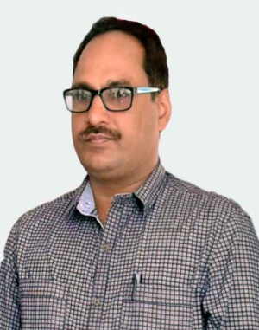
Baleshwar Yadav
+91-9431186047
byadav@stcchzb,.ac.in
New Forest Colony, Hurhuru Road, Hazaribag

SYNOPSIS
- An Assistant Professor of Computer Science domain with more than 14 years of experience of Teaching different Technologies (VB6.0,JAVA,C++,.NET and many more).
- Effectively manage and prioritize multiple responsibilities.
- Strong planning, organization and managerial skills with long time focus on the bottom line.
- Possess proven ability to establish and maintain positive interaction and rapport within department, with students and with the management.
- Guiding students and mentoring of fresher.

EDUCATION
M. Phil [Computer Science] MKU, Tamilnadu 2005
MCA IGNOU, New Delhi 2001
‘O’ Level DOEACC, New Delhi 1997
L.L.B Magadh University,Bihar 2004
B.A [Mathematics] Ranchi University, Ranchi 1989
I.Sc BIEC, Patna 1987
Matric BSEB, Patna 1984

DATE OF BIRTH: January 27, 1969

SEMINARS/WORKSHOP/ORIENTATION
- National Seminar on “Need for Vocational Education And Training in Jharkhand” organized by Ministry of HRD, Govt. of Jharkhand on 9th and 10th September 2008
- Presented a paper on the topic entitled “Mathematical Approach of Image Processing by using Fuzzy Logic” in the National Conference on Recent Trends in Mathematics and their Applications held on December 21-22, 2012
- Dissertation on Indexing Scheme for Images using fuzzy cluster.
- Participated Orientation programme for the Academic Counselors of BCA/MCA at Bhubaneshwar on 24th & 25th September 2011

EXPERIENCE
Asst. Professor of Degree Level [since 2001-till date]
St. Columba’s College, Hazaribag as
- Delivering Lectures on subjects assigned.
- Taking practical / lab sessions.
- Conducting Seminars on burning topics
- Control & manage the department as head of the department
- Arrange Special Classes for the students by Guest Faculty
- Over all observation of different activities of the department
- Responsibility of different Committee of the College

Assistant Co-ordinator [January 2002 – December 2015]
IGNOU Study Centre[0528], St. Columba’s College, Hazaribag
- Over all observation of different activities of the study centre
- Proper documentation and assign responsibility to concern personnel and monitoring the activities
Academic Counsellor [January 2002 to till date]
IGNOU Study Centre[0528], St. Columba’s College, Hazaribag

Observer
IGNOU Term End Examination June 2018 and December 2018

Technical Advisor
National Journal “The Intellectual Voice”

Subject Expert of the Selection Board
- Departmental Promotion Committee for appointment of PGT(Computer Science) at Sainik School, Telaiya
External Examiner
- Annada College, Hazaribagh
- K.B Womens College, Hazaribagh
- Concerned Colleges of VBU,
- IGNOU Study Center, Hazaribagh
- Makhan Lal Chaturvedy University Bhopal

Question Setter & Examiner
- L.N Mithila University, Darbhanga.
- Sidhu Kanhu University

Guest Faculty (Computer Science)-
- AISECT Institute of Professional Studies, Hazaribag Study center Punjab Technical University, Jalandher.
- St. Xavier’s School, Hazaribagh 10+2 level
- Dept of Telecommunication, Hazaribagh
- DRDA, Hazaribagh
- CCL, Charhi, Hazaribagh

Project Guide
- Guided more than 500 projects for BCA,MCA & B.E.

Signature

