FACULTY PROFILE
Geology
DEPARTMENT:
Shipra Chandra
NAME:
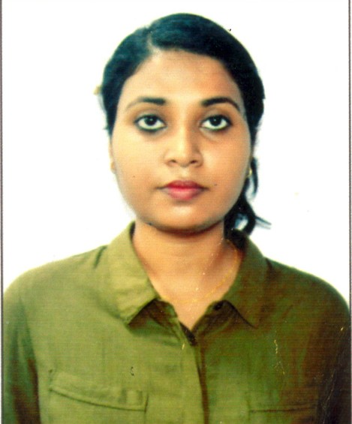
DIGITAL PHOTOGRAPH:

DESIGNATION: | Teacher Assistant Fellow
DATE OF JOINING THIS COLLEGE: | 10 th February 2021
TEACHING EXPERIENCE [at UG & PG level only]:

CONTACT NO.: | 6297346324
EMAIL ID: | chandrashipra30@gmail.com
ACADEMIC QUALIFICATIONS [PG & above only]: | Masters in Geology
SPECIALIZATION/RESEARCH AREA:

SUPERVISING RESEARCH SCHOLARS/ PURSUING RESEARCH:

RESEARCH PAPERS/ARTICLES:

EDITED/AUTHORED BOOKS:

AFFILIATION/ASSOCIATION WITH JOURNALS, etc.:

MEMBERSHIP/ATTACHMENT WITH DIFFERENT ASSOCIATIONS/INSTITUTIONS/BODIES/BOARDS:

ACHIEVEMENTS/FELICITATIONS/AWARDS RECEIVED:

ANY OTHER RELEVANT INFORMATION:

[SIGNATURE]

